Geoserver Installation Procedure
Download geoserver-2.6.3.exe from Geoserver Official Web sites (http://geoserver.org/download/)
Install geoserver-2.6.3.
Start Geoserver.
Open Geoserver Web admin page from start menu. Login
Click on Caching Default.
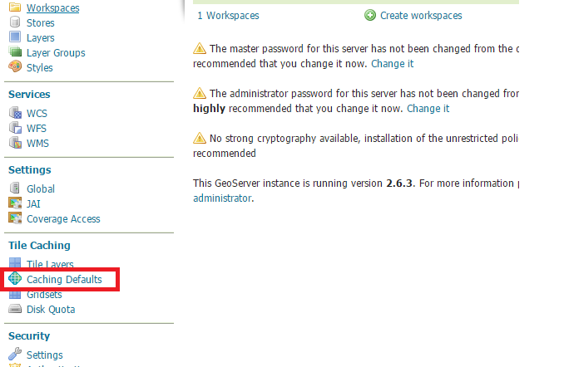
And Configure as par below screen shot.
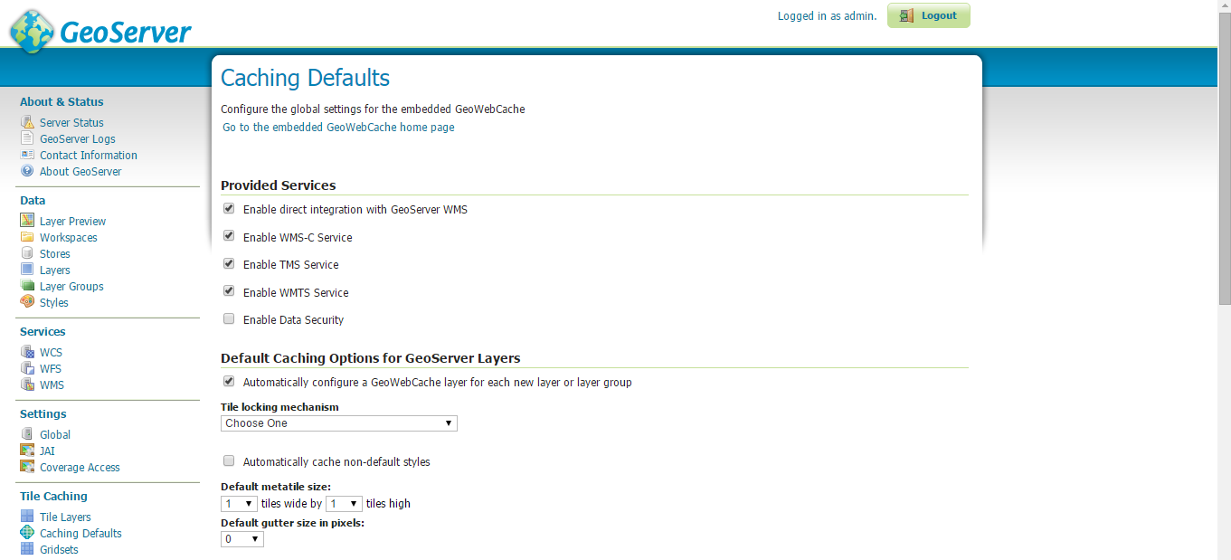
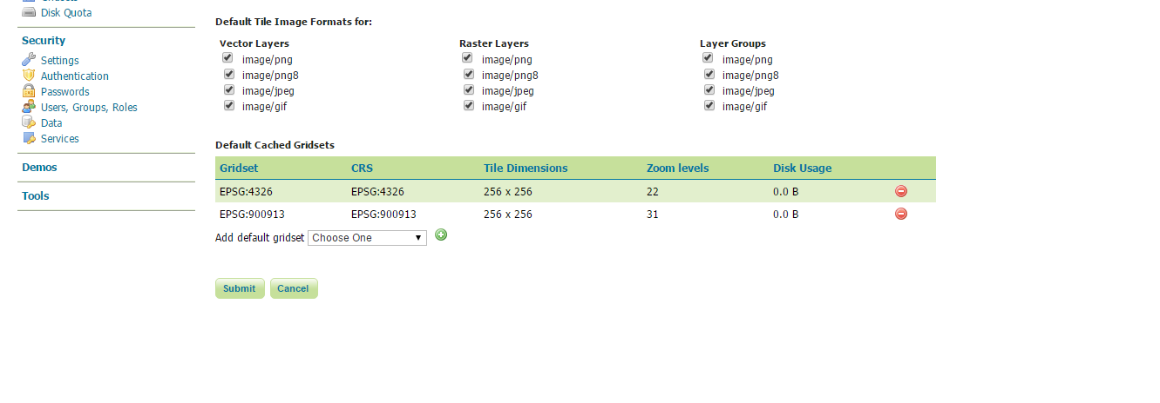

Changing the cache directory
GeoWebCache will automatically store cached tiles in a gwc directory inside your GeoServer data directory. To set a different directory, stop GeoServer (if it is running) and add the following code to your GeoServer web.xml file (located in the WEB-INF directory):

<context-param>
<param-name>GEOWEBCACHE_CACHE_DIR</param-name>
<param-value>C:\Program Files (x86)\GeoServer 2.6.3\data_dir\gwc</param-value>
</context-param>

Steps for ECW Image format
Installing GDAL extension
1. Download http://sourceforge.net/projects/geoserver/files/GeoServer/2.6.1/extensions/geoserver-2.6.1-gdal-plugin.zip
2. Extract the files to C:\Program Files (x86)\GeoServer 2.6.1\webapps\geoserver\WEB-INF\lib

Installing GDAL native library
Setup GDAL Data
1. Download http://demo.geo-solutions.it/share/github/imageio-ext/releases/1.1.X/1.1.10/native/gdal/gdal-data.zip
2. Extract this archive to C:\Program Files\GDAL\gdal-data
3. Create a GDAL_DATA environment variable to C:\Program File\GDAL\gdal-data
Setup GDAL
4. Download http:// demo.geo-solutions.it/share/github/imageio-ext/releases/1.1.X/1.1.10/native/gdal/windows/MSVC2010/gdal-1.9.2-MSVC2010.zip
5. Extract this archive to C:\Program Files (x86)\GDAL\gdal-1.9.2-MSVC2010
6. Add C:\Program Files (x86)\GDAL\gdal-1.9.2-MSVC2010 to your PATH.
7. Open command prompt, you should now be able to execute gdalinfo. If you can't there is something wrong with your PATH, or do a restart.
Update GeoServer Wrapper
8. Open and edit C:\Program Files (x86)\GeoServer 2.6.1\wrapper\wrapper.conf.
9. Add the following line wrapper.java.library.path.2=C:\Program Files (x86)\GDAL\gdal-1.9.2-MSVC2010 just after the wrapper.java.library.path1=bin/wrapper/lib line.
Install ECW Extension
10. Download http:// demo.geo-solutions.it/share/github/imageio-ext/releases/1.1.X/1.1.10/native/gdal/windows/MSVC2010/gdal-19-1600-ecw.msi
11. Install the package, which should installed to C:\Program Files (x86)\GDAL\gdalplugins
12. Create a GDAL_DRIVER_PATH environment variable to C:\Program Files (x86)\GDAL\gdalplugins

Changing the cache directory
GeoWebCache will automatically store cached tiles in a gwc directory inside your GeoServer data directory. To set a different directory, stop GeoServer (if it is running) and add the following code to your GeoServer web.xml file (located in the WEB-INF directory):
<context-param>
<param-name>GEOWEBCACHE_CACHE_DIR</param-name>
<param-value>C:\temp</param-value>
</context-param>

Change Data Directory
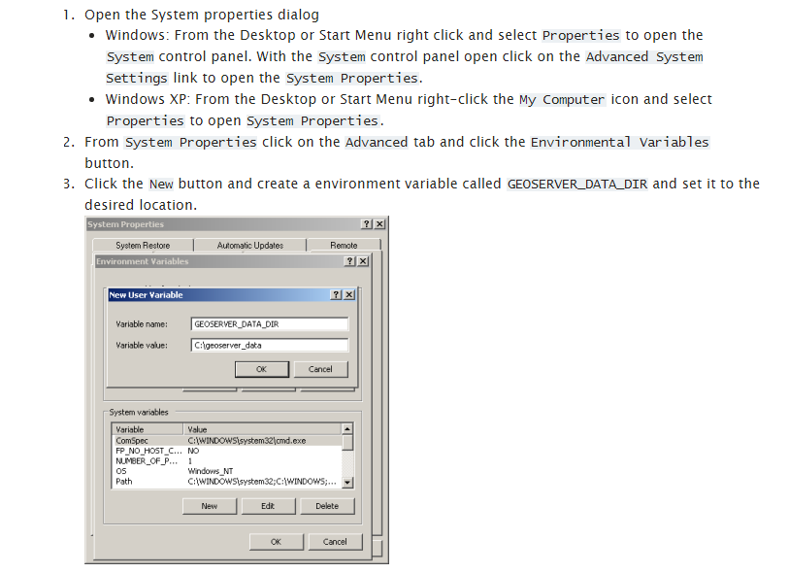

CORS Installation
1.Do not include the jar. Instead, put content of this archive http://shanbe.hezoun.com/cors.zip into the <Geoserver>\webapps\geoserver\WEB-INF\classes folder.
2. use <filter-class>org.mortbay.servlets.CrossOriginFilter</filter-class>
insteand of <filter-class>org.eclipse.jetty.servlets.CrossOriginFilter</filter-class>
3. do not use additional spaces in allowedHeaders defs (like this: "x-request-with, content-type")

You can put follwing conf. inside the <Geoserver>\webapps\geoserver\web.xml to allow CORS requests from all domains:

<filter>
<filter-name>cross-origin</filter-name>
<filter-class>org.mortbay.servlets.CrossOriginFilter</filter-class>
<init-param>
<param-name>allowedOrigins</param-name>
<param-value>*</param-value>
</init-param>
<init-param>
<param-name>allowedMethods</param-name>
<param-value>GET,POST</param-value>
</init-param>
<init-param>
<param-name>allowedHeaders</param-name>
<param-value>x-requested-with,content-type</param-value>
</init-param>
</filter>

<filter-mapping>
<filter-name>cross-origin</filter-name>
<url-pattern>/*</url-pattern>
</filter-mapping>

